This form must be completed for all electronic door opener requests. Attach this form to a completed Equipment Prescription/Request Form and email to the Equipment Program at DHSEquipmentProgram@sa.gov.au
An electronic door opener has two components that need to be considered for provision:
- the door opener
- the switch access
Consideration and recommendations must be given to both aspects of the prescription.
The standard provision is:
- 2 x remote switches (usually one in the bedroom and one for the wheelchair)
- 1 x internal push button (usually used by staff / family)
- 1 x external key pad
- Automatic strike lock

SECTION 1: ASSESSOR TO COMPLETE
Client Name |  | Client Phone
Assessor Name |  | Assessor Phone
Information about House
Address
Year house built / approx. age of house
Electronic Door Opener Specifications
Note: The Equipment Program uses Dorma for the supply and installation of the door opener
Proposed System and Model Number | ED100 (up to 1100mm door width)  ED250 (door width greater than 1100mm)
Which door in the home is having the electronic door opener installed?
Does the doorway require widening? No Yes, specify clear width required mm
Is a Combi door required? No Yes
Remote switch requirements
Note: OT assessment and recommendations required
Does the client require a specialised switch? No Yes - If yes, provide details about
the switch you have assessed to be the most appropriate:
Examples of switches that can be provided:
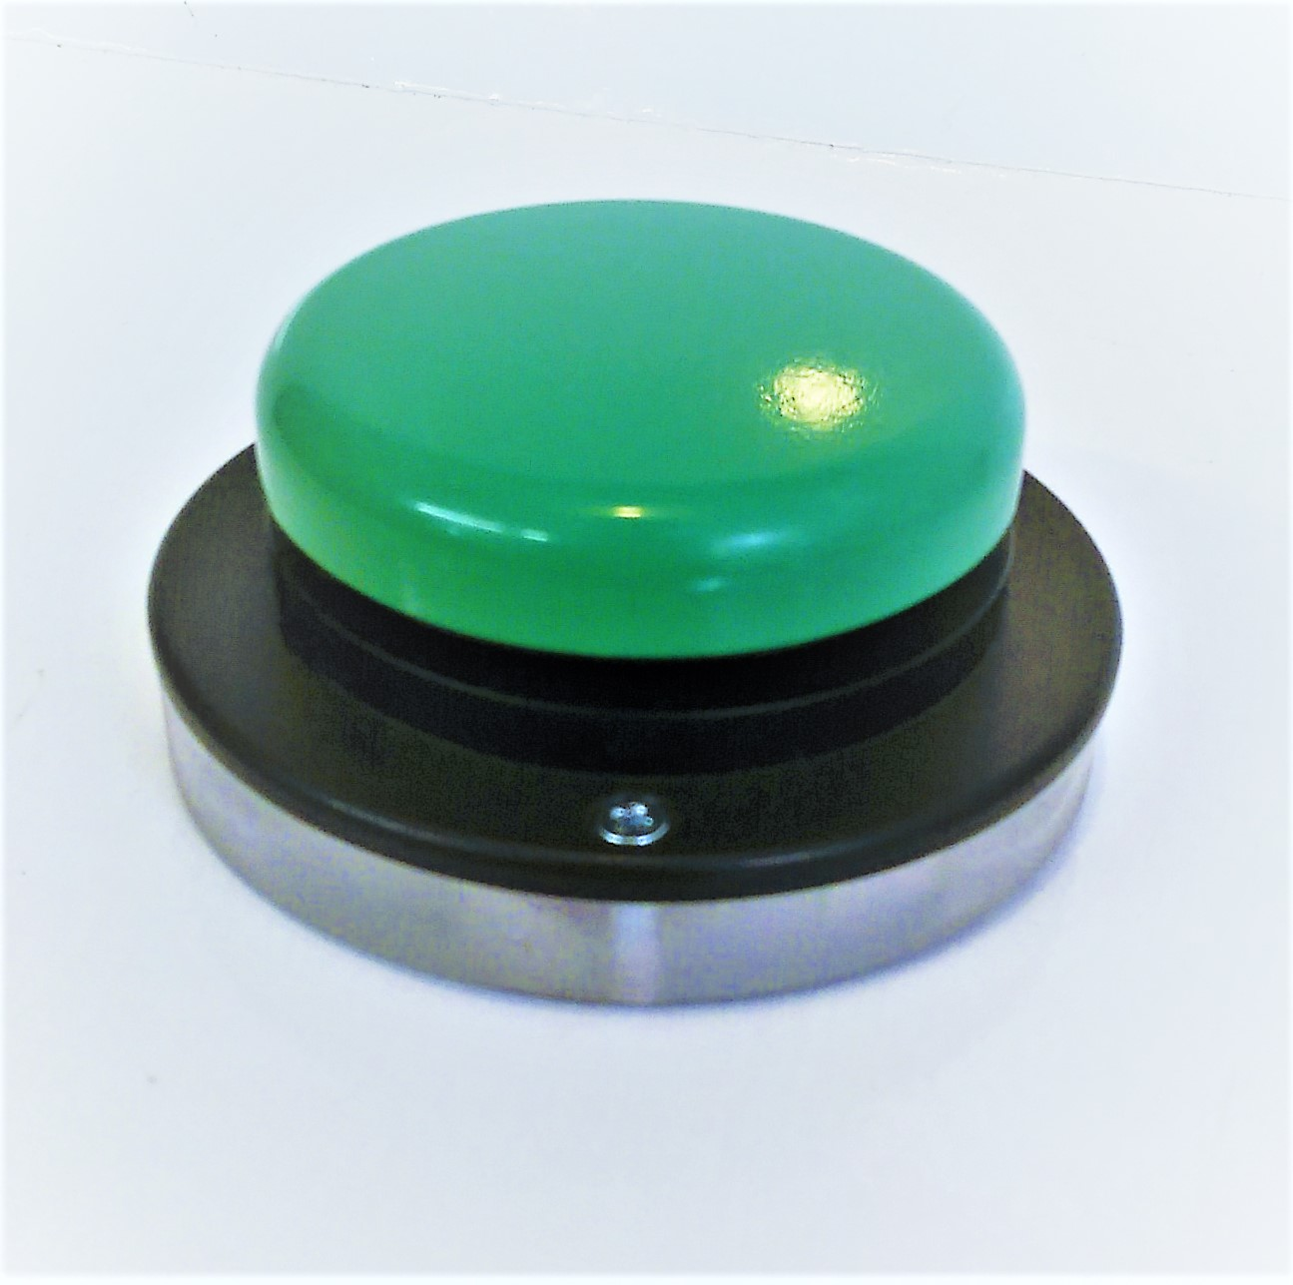 | jellybean transmitter only (standard supply) | 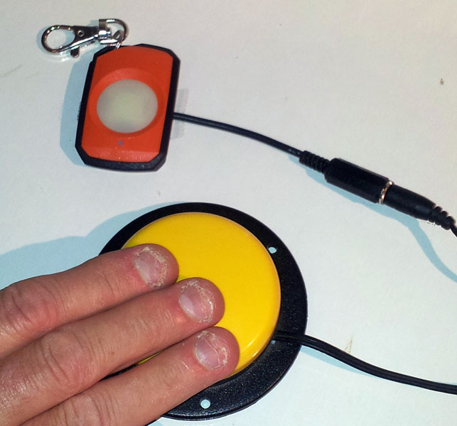 | radio linked pendant, adapted | 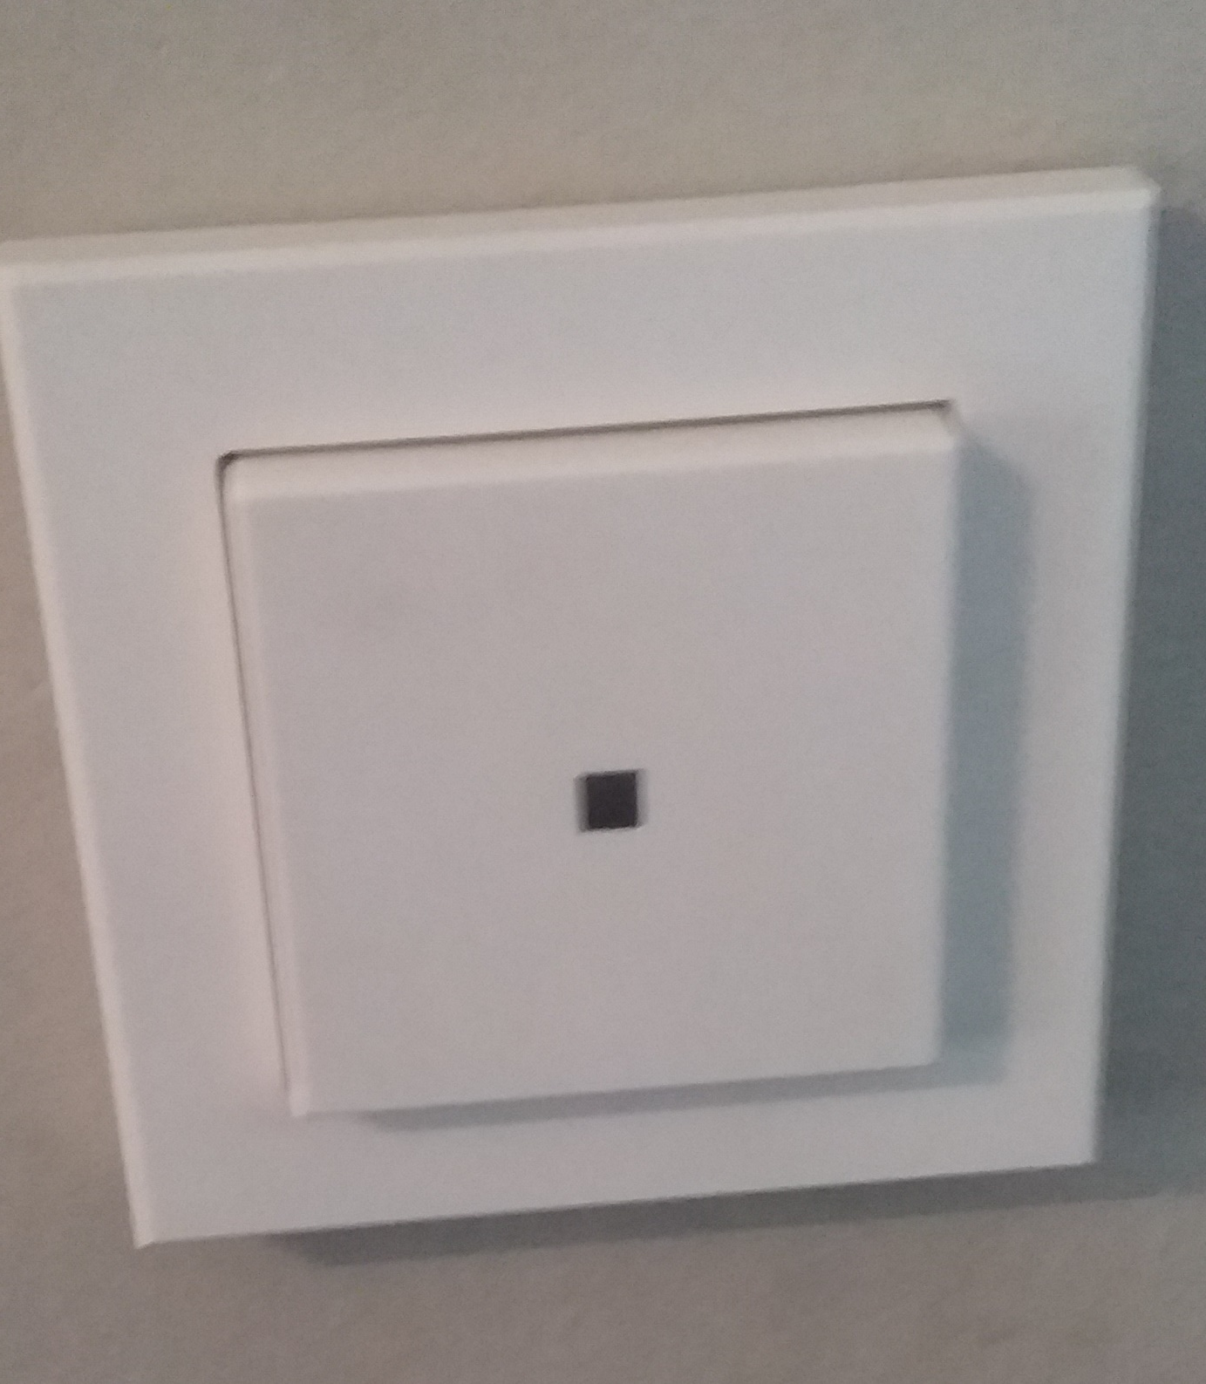 | Square wall button

Which part of the body will the person use to access the switch (e.g. hand, finger, knee, elbow, breath, proximity etc)?

Where does the wheelchair switch need to be positioned?

Where does the bedroom switch need to be positioned?

Assessor Checklist
Equipment Prescription/Request Form completed
Image of existing door provided
Copy of relevant approvals sent to the Equipment Program (if homeowner is Housing SA or other Community Housing Group)
The “Terms and Conditions for Provision of Home Modifications” document has been provided to the participant / advocate / guardian and the home owner (where these people are different)
SECTION 2: CLIENT / GUARDIAN / ADVOCATE TO COMPLETE
I have been involved in the decision making and to the best of my knowledge I believe the recommendations will meet the needs of those using the electronic door opener and any associated modifications listed above.
I understand that this is subject to final consultation with the installer and approval by the funder.
I agree for the Equipment Program to coordinate the installation of the recommended electronic door opener and any associated modifications through an appropriately qualified installer.
I have received, read, understood and accept the “Terms and Conditions for Provision of Home Modifications”.

I am the home owner, and I give permission for the installation of the electronic door opener and any associated modifications listed above into my home,
OR
I am not the home owner (private home owner to complete section 3)
Signature Date
Name Best Contact Number
SECTION 3: OWNER OF THE PROPERTY (if different to section 2)
I, the owner of this dwelling, give permission for the installation of the electronic door opener and any associated modifications listed above into my home
NB: where the home owner is government or community housing, forward any additional approval forms required by that group to the Equipment Program.
I agree for the Equipment Program to coordinate the installation of the recommended electronic door opener and any associated modifications through an appropriately qualified installer.
I have received, read, understood and accept the “Terms and Conditions for Provision of Home Modifications”.
Signature Date
Name Best Contact Number

